SAFETY MANUAL
JEFFERSON COUNTY LITTLE LEAGUE
ESTABLISHED IN 1953
P.O. BOX 339 RANSON, WV 25438
LEAGUE ID NUMBER – 348-06-07
Table of contents
Board of Director Information 2
ASAP Mission 3
Introduction /Policies 4-23
Appendices 24-41
Appendix A – Volunteer Form 25
Appendix B – Injury Tracking Form 26
Appendix C – Medical Release Form 27
Appendix D – General Liability Claim Form 28
Appendix E – Concession Stand Safety 29-30
Appendix F – General Safety 31
Appendix G – Head Injuries 32
Appendix H – Dislocations 33
Appendix I – Broken Bones 34
Appendix J – Strains and Sprains 35
Appendix K – Nosebleeds 36
Appendix L – Cuts 37
Appendix M – Dehydration 38
Appendix N – Heat Illness 39
Appendix O – First Aid Kits 40-41
Appendix P – Covid Policies and Guidelines 42-43
Appendix Q – AED Policy 44 Appendix R – CPR 45-59
Parent Code of Conduct /Addendum 60-61


Jefferson County Little League Phone Numbers

Emergency | 911
Jefferson County Sheriff Department | 304-728-3205
Jefferson County Emergency Services Agency | 304-728-3287
Fire: Independent Fire Company | 304-725-2514
Director of Safety Coordination: Keith Kain Jr | 304-995-3001

Jefferson County Little League Board Members

Name | Position | Phone | Email
Bryan Sutherland | President | (240) 315-2925 | jcllwvpresident@gmail.com
Greg Stevens | Vice President | (304) 676-1747 | pappystevens@hotmail.com
Kevin Horn | Umpire-in-Chief, Baseball | (304) 616-6550 | UIC4jcll@gmail.com
April Counselman | Tee Ball & A Director | (703) 727-7715 | teeballdirector4jcll@gmail.com
Kevin Corey | Minors AAA/AA  Director | (703) 371-9346 | kcorey11@gmail.com
Kristin Stoner | Softball Director | (724) 244-5595 | softball4jcll@gmail.com
Robert Group | Juniors Director | (717) 816-0869 | juniorsbb4jcll@gmail.com
Amanda  Impellizzeri | Fundraising Director | (301) 928-0040 | fundraising4jcll@gmail.com
Kaysie Staubs | Softball Player Agent | (304) 433-1855 | playeragent4jcllsoftball@gmail. co m
Andrea Hudson | Baseball Player Agent | (304) 582-2738 | playeragent4jcll@gmail.com
Keith Kain Jr | Safety Coordinator | (304) 995-3001 | keithkain11@icould.com
Ryan Cefalu | Umpire-in-Chief  Softball | (540) 326-6909 | jcllsoftballuic@gmail.com
Anthony Thomas | Coaches Coordinator | (540) 409-8593 | anthonythomas84@gmail.com
Rick Hahn | Fields & Facilities Director | (304) 279-5765 | rickhahn70@gmail.com
AJ Mason | Equipment Manager | (304) 995-9874 | jamesallanmason@gmail.com
Greg Sager | Majors Director | (304) 283-2208 | sager65@yahoo.com
Larry Guerra | Board Member at Large | (304) 279-4051 | lawguerra@yahoo.com
Kendell Burke | Treasurer | (304) 886-8821 | treasurer4jcll@gmail.com
Sarah Kain | Secretary, CIO | (304) 995 6397 | secretary4jcll@gmail.com
 |  |  | grantcoordinator@gmail.com
Brandy Beery | Grants Coordinator | (304) 596-7599


THE ASAP MISSION
To increase awareness of the opportunities to provide a safe and secure environment for
children.

Introduction
Jefferson County Little League (JCLL) is a fully chartered Little League open to boys and girls between the ages of 4-14 living within the boundaries for JCLL as determined and approved by Little League Baseball®. We play within the District 6 of the Southeast Region of Little League Baseball®. JCLL consists of the following Divisions:

Tee Ball (ages 4-6), Minors, (“A”, “AA”, “AAA”), Majors, Intermediate, and Junior Baseball as well as Minor, Major and Junior Softball

Each of these Divisions contains teams within each of the following levels:

Tee-Ball
Consists of 4-6 year old’s playing organized baseball for the first time. The ball is hit from a tee at home plate and where hitting, throwing, and catching a baseball is taught for the first time.
Minor Leagues
“A”: Consists of 6-7 year olds. Introduction to pitched balls is made through “coach pitch” or using a “pitching machine” using regulation Little League® baseballs. Protective cups are recommended for players but required for anyone playing the “catcher” position.
“AA”: Consists primarily of 7-8 year olds. “Coach pitch” and “kid pitch” is utilized during the season. Little League balls are used and protective cups are required.
“AAA”: Is the first draft Level and consists primarily of 8-11-year olds. Players are pitched to by another player.
Majors (also referred to as “Little League”): Consists of skilled and experienced 9-12-year old.
Junior: Consists of 13 – 14-year old playing on fields using the conventional 90’ diamond with a pitching distance from 60 feet, 6 inches.
Minor League Softball: Minor league softball is for girls of league age 7 to 12 years old.
Major League Softball: Major League Softball is for girls of league age 9 to 12 years old.
Junior League Softball: Junior League Girls Softball is for girls of league age 13 to 14 years old.
JCLL started a Safety Plan that was initially authored with spring baseball in mind; the Safety Plan is also in effect and enforced for the post season programs as well such as “The Second Season” or “Fall Ball”.
JCLL has long shown a commitment to the safety and well-being for all those involved in all of our divisions of play. It is an active and willing participant in Little League’s “A Safety Awareness Program” (ASAP).

ASAP
In 1995, ASAP (A Safety Awareness Program) was introduced with the goal of re-emphasizing the position of Safety Officer “to create awareness, through education and information, of the
opportunities to provide a safer environment for kids and all participants of Little League Baseball®”. To be an ASAP- compliant league, a Little League® approved Safety Plan must be filed with Little League International in Williamsport, PA.

JCLL Safety Plan
The goal of the Safety Plan is to develop guidelines for increasing the safety of activities, equipment, and facilities through education, compliance, and reporting. In support of the attainment of this goal, JCLL also commits itself to providing the necessary organizational structure to develop, monitor, and enforce the aspects of the plan.

The Safety Plan, by reference, includes JCLL’s Safety Code, JCLL’s Code of Conduct, and the JCLL Safety Manual. The combination of these documents outlines specific safety issues and JCLL’s policy or procedure for each issue. All participants, volunteers, employees, spectators, and guests are bound by the guidelines set forth in these documents.

Safety Officer
One of the elected members is the Safety Officer. They act as JCLL’s primary point of contact for the creation and enactment of the Safety Plan. The Safety Officer authors or modifies the League’s Safety Plan, Code of Conduct, Safety Code, and Safety Manual each year, as necessary. These documents are then presented to the board for approval and ratification
(usually in February or March) for the upcoming season. A copy is then to be given to each Board member and Manager/Coach.

Ongoing in This Season
Each year, JCLL looks for specific ways to create awareness, through education and information, of the opportunities to provide a safer environment for kids and all participants of Little League Baseball®. Some of the specific initiatives the league will enact this season:

- No Casts. Casts may not be worn in the playing area. Players, coaches, managers, and umpires wearing casts must remain in the dugout during the game.
- Alcohol Prohibited – New language making it clear that alcohol is prohibited at the game site.
- Baseball Bat Alteration – Altered bats are to be removed from play.
- Tobacco Use Prohibited – No player, coach, manager, umpire, or spectator may use any tobacco (including smokeless) while on JCLL grounds.

JCLL continues to maintain initiatives developed in the past years including but not limited to:

- Background checks – JCLL will continue its scope in performing criminal background checks on league officials, managers, coaches, volunteers; any adult who has interaction with children.

- JCLL understands the extreme importance of background checks and the safety of our children. The league President performs all background checks for JCLL.

- Updated street addresses for JCLL fields – For faster arrival of first responders, educating managers and coaches to be as familiar with their home field locations as they are with their residential and
business addresses. Fields are now posted on the JCLL website. http://www.jcllwv.com. The physical address for the JCLL fields complex is 1106 Shenandoah Junction Road, Shenandoah Junction, WV
25442

- Pitch counts – To protect the arms of players, JCLL strictly follows the policies and procedures of Little League® by monitoring pitchers as well as maintaining a comprehensive pitch count log.

- Break away bases – To reduce injuries related to bases staked into the playing surface, Little League® has been requiring disengage-able bases on all fields. JCLL does utilize breakaway bases.

- Continuous Learning – Managers, coaches and parents on ways to prevent injury using proper mechanics and technique.

Board Meetings
The Board meets at least once every month on the first Sunday of each month. Dates and times of Board meetings can be obtained from the league calendar on the JCLL website. All active members are welcome and encouraged to attend.

The Safety Officer is included on every meeting’s agenda. Besides providing an opportunity for the
Safety Officer to inform and update the other Board members on the status of certain safety initiatives (whether they be at the local, District or Headquarters level), it also ensures the continued awareness and attention to the subject of safety within the JCLL Safety Committee.

Rules Committee
This committee, consisting of the President of the Board of Directors, the Umpire-in-Chief and the Vice President of the Board of Directors, is responsible for drafting any proposed new or modified Local Rules for JCLL. Areas such as competitive balance, player participation, speed of play, and safety are discussed, and any changes or additions are presented to the Board for discussion and/or ratification. Every year, this committee evaluates existing Local Rules and considers any necessary changes and/or additions to these rules.

Sex Offender Background Checks Procedure
Effective in 2007, the local league must conduct a nationwide search that contains the applicable government sex offender registry data. Little League International has contracted with J.D. Palatine (JDP) to provide local leagues and districts with a special Internet site that allows members to search a criminal records database of more than 450 million criminal records - instantly. This site provides searches of available criminal records from various repository sources and state-level sex offender registries. The fee for the first 125 searches per chartered league and district is free to the local league and district as the cost for these searches is being provided by Little League International.

JCLL will use JDP to perform the background checks. As always, JCLL will render a volunteer candidate ineligible if their name is discovered with any crime against a child or appears on a sex offender registry
(SOR). In addition to the important task of protecting children, this endeavor ensures our volunteers match Little League Baseball’s® commitment to character, commitment and loyalty. You will find a copy of the volunteer form at www.jcllwv.com.

Each year JCLL looks for specific ways “to create awareness, through education and information, of the opportunities to provide a safer environment for kids and all participants of Little League Baseball®”. We believe that the Safety Plan that follows provides for the maximum opportunity to put forth a formal methodology that can be easily repeated and reused from year to year. We also believe that the plan accommodates new recommendations and initiatives that can be “rolled” into the plan for the future.

Equipment
Little League Baseball® provides a comprehensive list of mandatory as well as optional equipment to help reduce injuries associated with the game. JCLL has a dedicated.
Equipment Manager on a board level position to ensure not only there is sufficient stock on hand but to make certain it is in an unbroken condition.

While JCLL provides basic safety equipment for team use, players are responsible for providing their own personal safety equipment. A list of equipment required will be presented by managers, coaches and team parents during the first team meeting. Managers and coaches (Home Team) as well as umpires inspect the field and all equipment prior to each game. Unsafe equipment is removed from the game and returned to the Equipment Manager for destruction and replacement.

Required Field Equipment:
- 1st, 2nd and 3rd bases that disengage from their anchors.
- Pitcher’s plate and home plate
- Players’ benches behind protective fences
- Protective backstop and sideline fences
Optional Field Equipment:
- Double 1st base that disengages from its anchor. Currently our “Tee Ball/Minor Field is configured this way.
- Baseball mound for pitcher’s plate (Note: Used on select fields by JCLL)
- Portable pitcher’s baseball mound with pitcher’s plate
- Protective/padded cover for fence tops (Note: used on select fields by JCLL) - Foul
ball return in backstop fencing
Required Player Equipment: Defense Mandatory:
- Athletic supporter – all male players
- Metal, fiber, or plastic type cup – all male catchers
- Catcher’s helmet and mask, with “dangling” throat guard; NO skull caps – all catchers; must be worn during pitcher warm-up, infield practice, while batter is in box - Catcher’s mitt – all baseball catchers
- Chest protector and leg protectors – all catchers; must be worn while batter is in box; long model chest protector required for Little League (Majors) and younger catchers
Defense Optional:
- Metal, fiber or plastic type cup – any player, especially infielders
- Pelvic protector – any female, especially catchers
- Heart Guard/XO Heart Shield/Female Rib Guard – any defensive player, especially pitchers, infielders
- Game-face safety mask – any player, especially infielders
- Goggles/Shatterproof glasses – any player, especially those with vision limitations
Offense Mandatory:
- Helmet meeting NOCSAE (National Operating Committee on Standards for Athletic Equipment) standards – all batters, base runners and players in coaches’ boxes.
- Regulation-sized ball for the game and division being played; marked RS for regular season or RS-T for regular season and tournament in baseball respectively.
- The bat for baseball must be a baseball bat which meets the USA Baseball Bat standard as adopted by Little League and in accordance with rule 1.10 of the baseball rule book depending on the division in which the player is participating.
- The bat for softball must be a softball bat which meets Little League specifications and standards as noted in rule 1.10 of the softball rule book. Non-wood bats shall be printed with a BPF (bat performance factor) of 1.20
Offense Optional:
- Helmet – adults in coaches’ boxes.
- Helmet with Face Guards or C-Flap meeting NOCSAE standards – all batters, especially in younger divisions.
- Helmet chinstrap – all helmets made to have chinstrap (with snap buttons, etc.) - Mouth guard – batters, defensive players.
- Goggles/Shatterproof glasses – any player, especially those with vision limitations
- Batters vest, Heart Guard/Heart Shield/Female Rib Guard – any batter - Regulation sized reduced impact ball

Little League Baseball® has a rich history of pioneering baseball safety innovations. Following recommendations from researchers and medical professionals in the field of sports medicine, it has been determined that the actual number of pitches thrown is a safer method to regulate pitching in youth baseball. The maximum number of pitches allowed are dependent upon league age.

Since 2010, Little League Baseball® has aligned regular season and tournament pitching rules. Pages 38-39 of the Little League Baseball® Green Book describes in detail how the pitch count is to be administered. Below is a general overview of Little League Baseball’s® pitch count rules:
VI - PITCHERS
Baseball
- Any player on a regular season team may pitch. Exception: Any player who has played the position of catcher in four (4) or more innings in a game is not eligible to pitch on that calendar day.

- A pitcher once removed from the mound cannot return as a pitcher. Junior Division only: A pitcher remaining in the game, but moving to a different position, can return as a pitcher anytime in the remainder of the game, but only once per game.

- The manager must remove the pitcher when said pitcher reaches the limit for his/her age group as noted below, but the pitcher may remain in the game at another position:

League Age Maximum Pitches
17-18 | 105 pitches per day
13-16 | 95 pitches per day
11-12 | 85 pitches per day for
9-10 | 75 pitches per day
7-8 | 50 pitches per day

Exception: If a pitcher reaches the limit imposed in Regulation VI (c) for his/her league age while facing a batter, the pitcher may continue to pitch until anyone of the following conditions occurs: 1. That batter reaches base; 2. That batter is put out; 3. The third out is made to complete the half-inning. Note 1: A pitcher who delivers 41 or more pitches while not covered by the threshold exception in a game cannot play the position of catcher for the remainder of that) Pitchers league age 14 and under must adhere to the following rest requirements:

- If a player pitches 66 or more pitches in a day, four (4) calendar days of rest must be observed.
- If a player pitches 51 - 65 pitches in a day, three (3) calendar days of rest must be observed.
- If a player pitches 36 - 50 pitches in a day, two (2) calendar days of rest must be observed.
- If a player pitches 21 - 35 pitches in a day, one (1) calendar day of rest must be observed.
- If a player pitches 1 - 20 pitches in a day, no rest must be observed.
- Note: Under no circumstance shall any player pitch three consecutive days.

- Each league must designate the scorekeeper or another game official as the official pitch count recorder.

- The pitch count recorder must provide the current pitch count for any pitcher when requested by either Manager or any umpire. However, the manager is responsible for knowing when his/her pitcher must be removed.

- The official pitch count recorder should inform the umpire-In-chief when a pitcher has delivered his/ her maximum limit of pitches for the game, as noted in regulation VI (c). The umpire-in-chief will inform the pitcher’s manager that the pitcher must be removed in accordance with regulation VI (c). However, the failure by the pitch count recorder to notify the umpire-in-chief, and/or the failure of the umpire-in-chief to notify the manager, does not relieve the manager of his/her responsibility to remove a pitcher when that pitcher is no longer eligible.

- Violation of any section of this regulation can result in protest of the game in which it occurs. A protest shall be made in accordance with Playing Rule 4.19.

- A player who has attained the league age of twelve (12) is not eligible to pitch in the Minor League. (See Regulation V - Selection of Players).

- A player may not pitch in more than one game in a day. (Exception: In the Big-League Division, a player may be used as a pitcher in up to two games in a day).

- Players selected from the pool to play for another team are ineligible to pitch for that team.

- A pitcher who delivers 41 or more pitches in a game cannot play the position of catcher for the remainder of that day.

NOTES:

- The withdrawal of an ineligible pitcher after that pitcher is announced, or after a warm-up pitch is delivered, but before that player has pitched a ball to a batter, shall not be considered a violation. Little League officials are urged to take precautions to prevent protests. When a protest situation is imminent, the potential offender should be notified immediately.

- Pitches delivered in games declared “Regulation Tie Games” or “Suspended Games” shall be charged against pitcher’s eligibility.

- In suspended games resumed on another day, the pitchers of record at the time the game was halted may continue to pitch to the extent of their eligibility for that day, provided said pitcher has observed the required days of rest.

Example 1: A league age 12 pitcher delivers 70 pitches in a game on Monday when the game is suspended. The game resumes on the following Thursday. The pitcher is not eligible to pitch in the resumption of the game because he/she has not observed the required days of rest.

Example 2: A league age 12 pitcher delivers 70 pitches in a game on Monday when the game is suspended. The game resumes on Saturday. The pitcher is eligible to pitch up to 85 more pitches in the resumption of the game because he/she has observed the required days of rest.

Example 3: A league age 12 pitcher delivers 70 pitches in a game on Monday when the game is suspended. The game resumes two weeks later. The pitcher is eligible to pitch up to 85 more pitches in the resumption of the game, provided he/she is eligible based on his/her pitching record during the previous four days. Note: The use of this regulation negates the concept of the “calendar week” regarding pitching eligibility.

JCLL has furnished the complete copy of the Little League Baseball® Pitch Count Regulation
Guide to all board members, managers and coaches. JCLL will document pitch counts by use of a
Little League® Baseball Game Pitch Log as well as Little League Baseball® Pitcher Eligibility Tracking Forms that will be signed by both opposing managers. A scorekeeper or volunteer can be assigned to perform pitch count entries; however, each manager owns the accuracy and accountability of the pitch count.

Completed pitch logs and eligibility tracking will follow the same routing as the score sheet to the President of JCLL or the assigned board representative.

Softball

- Any player on the team roster may pitch. EXCEPTION: A player who has attained a league age of twelve
(12) is not eligible to pitch in the Minor League.

- Minors/Little League (Majors): A player may pitch in a maximum of twelve (12) innings in a day. If a player pitches in seven (7) or more innings in a day, one calendar day of rest is mandatory. Delivery of a single pitch constitutes having pitched in an inning.

First Aid
All JCLL managers and coaches will receive general first-aid training before the season begins. First-aid kits will be distributed to the Managers at the beginning of the season. Ice and bandages are also available at the concession stand. At least one representative of each team must attend. Managers must have a first-aid kit at every game or practice.

Little League Baseball® uses an acronym called PRICES to help remember the basics of first aid:

- Protection – When a player feels pain or just “something wrong”, he or she should stop immediately to protect the area from further harm. If a player “plays through the pain,” he or she risks further injury, delayed recovery and more pain.
- Rest – Not playing until recovery is complete; don’t use the arm, stay off the leg or use a crutch to properly rest a limb if appropriate.
- Ice – should be applied as soon after an injury as possible to reduce swelling and inflammation. Apply ice for no more than 5-10 minutes and then remove for 5-10 minutes, repeating the cycle several times. Apply the ice over a towel or other dressing, and make sure the skin does not come in direct contact with the ice. Ice the area several times each day. Be careful to watch the skin color to avoid damage to the skin; when the skin is pink for light-skinned players or darker for dark-skinned athletes, remove the ice.
- Compress – the injured area to further reduce swelling, which if not controlled can put
pressure on muscles and connective tissues, causing damage. Use elastic bandages, air casts or splints. This should be done carefully, as circulation can be restricted if done improperly; if throbbing begins, loosen the wrapping.
- Elevate – the area when possible, above the heart to further reduce swelling.
- Support – Keep the limb supported and protected from further harm.

Code of Conduct
The JCLL Code of Conduct has been adopted by the Board of Directors. This Code is enforced by the Safety Officer, the League President, and the League Directors. All league officers, participants, employees and volunteers are required to abide by this code. It is the job of the Safety Officer to author and/or make any revisions to this Code of Conduct from year to year, as necessary.

JCLL Code of Conduct
- Speed limit 5 mph in roadways and parking lots while attending any JCLL function.
- Watch for small children around parked cars.
- No alcohol or tobacco is allowed in any parking lot, field, or common areas within the JCLL complex.
- No playing in parking lots at any time.
- No playing on or around lawn equipment.
- Use crosswalks when crossing roadways. Always be alert about traffic.
- No profanity.
- No swinging bats at any time within the walkways and common areas of the JCLL complex.
- No throwing balls against dugouts or against backstop.
- All gates to the field should always remain closed. After players have entered or left the playing field, all gates should be closed and secured.
- No throwing baseballs at any time within the walkways and common areas of the JCLL complex. Caution should be exercised with kids playing “wall ball” against the side of the concession stand. Only tennis balls should be used.
- No throwing rocks.
- No horse play in walkways at any time.
- No climbing fences.
- No pets are permitted at games or practices.
- Only a player on the field and at bat may swing a bat (Age 4-12). Intermediate/Juniors (Age 11-13) on the field at bat or on deck may swing a bat. Be Alert of area around you when swinging a bat while in the on-deck position.
- Observe all posted signs. Players and spectators are to always alert for foul balls and errant throws.
- During a game, players must remain in the dugout in an orderly fashion at all times.
- After each game, each team must clean up trash in dugout and around stands.

Failure to comply with this Code of Conduct may result in expulsion from the Complex.

Coaches and Managers Training
JCLL requires all coaches and managers to attend a training seminar/managers meeting. The managers’ meeting is scheduled for Saturday, March 8th, 2025. For the most current and complete list of training seminars please visit our website at: www.jcllwv.com.

Safety Code
The JCLL Safety Code has been adopted by the Board of Directors and is enforced by the Safety Officer. All league officers, participants, employees, and volunteers are required to abide by this code.

It is the job of the Safety Officer to make any revisions to the Safety Code from year to year, as necessary.

JCLL Safety Code
- Responsibility for safety procedures should be that of an adult member of JCLL.
- Managers, coaches and umpires should have training in first aid. First-aid kits are distributed to managers and extras are located at the concession stand.
- Managers of the home team will be responsible for inspecting the field for holes, damage, stones, glass and other foreign objects prior to games or practices.
- In games where umpires are presiding, the umpire will ensure that field inspections have been carried out by the managers. Umpires have the discretion to call the game if it is determined that the field is not suitable for play.
- No games or practices should be held when weather or field conditions are not good, particularly when lighting is inadequate.
- All team equipment should be stored within the team dugout, or behind screens, and not within the area defined by the umpires as “in play”.
- Only players, managers, coaches, and umpires are permitted on the playing field or in the dugout during games and practice sessions.
- Responsibility for keeping bats and loose equipment off the field of play should be that of a player assigned for this purpose or the team’s manager and coaches.
- A procedure should be established for retrieving foul balls batted out of the playing area.
- During practice and games, all players should be alert and watch the batter on each pitch.
- During warm-up drills, players should be spaced so that no one is endangered by wild throws or missed catches.
- Equipment should be inspected regularly for the condition of the equipment as well as for proper fit.
- Batters must wear Little League Baseball® approved protective helmets during batting practice and games.
- The catcher must wear catcher’s helmet, mask, throat guard, long model chest protectors, shin guards and protective cup with athletic supporter at all times (males) for all practices
and games. NO EXCEPTIONS. Managers should encourage all male players to wear protective cups and supporters for practices and games.
- Except when a runner is returning to base, headfirst slides are NOT permitted.
- During sliding practice, bases should not be strapped down or anchored.
- At no time should “horse play” be permitted on the playing field.
- Parents of players who wear glasses should be encouraged to provide “safety glasses”.
- Players must not wear watches, rings, pins or metallic items during games and practices.
- The Catcher must wear a catcher’s helmet and mask with a throat guard in warming up
pitchers.
This applies between innings and in the bullpen during a game and also during practices.
- On-deck batters are not permitted.
- All pre-game warm-ups should be performed within the confines of the playing field and not within areas that are frequented by, and thus, endanger spectators (i.e., playing catch, pepper, swinging bats, etc.).

Injury Reporting Procedures
The following reporting procedures should be used by all managers, coaches, parents, umpires, and volunteers concerning injuries.

What to report - An incident that causes any player, manager, coach, umpire, or volunteer to receive medical treatment and/or first aid must be reported to the Safety Officer. The terms “medical treatment and/or first aid” include even passive treatments such as the evaluation and diagnosis of the extent of the injury. Any incident that (a) causes a player to miss any practice or game time; or (b) any event that has the potential to require medical assistance must be reported promptly.

When to report - All such incidents described above must be reported to the
Safety Officer within 24 hours of the incident. The Safety Officer for 2025 is Keith Kain Jr, and he can be reached at the following Email: keithkain11@yahoo.com / 304-995-3001.

How to make the report – reporting incidents can come in a variety of forms.
Most typically, they are by way of Incident/Injury Tracking Report (Appendix B). At a minimum, the following information must be provided:

- The name and phone number of the individual involved (or of their parents)
- The date, time and location of the incident
- As detailed a description of the incident as possible
- The preliminary estimation of the extent of any injuries
- The name and phone number of the individual reporting the incident

Safety Officer’s Responsibilities - The Safety Officer will receive this injury report and within 48 hours of receiving the incident report, the Safety Officer will contact the injured party or the party’s parents and (1) verify the information received; (2) obtain any other information deemed necessary; (3) check on the status of the injured party; and (4) in the event that the injured
party required other medical treatment (i.e. Emergency Room visit, doctor’s visit, etc.) will advise the parent or guardian of the JCLL insurance coverage through Chartis and the provisions for submitting any claims for reimbursement.

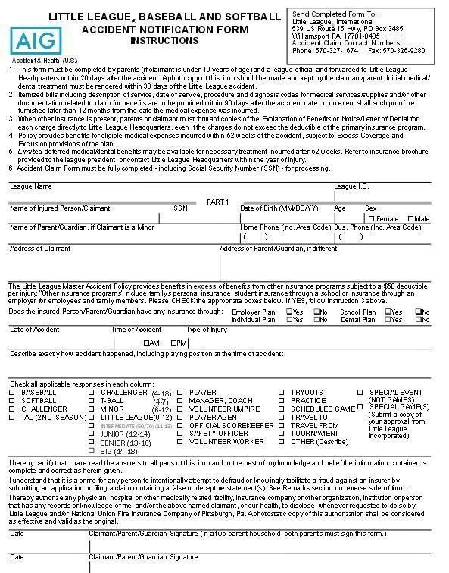

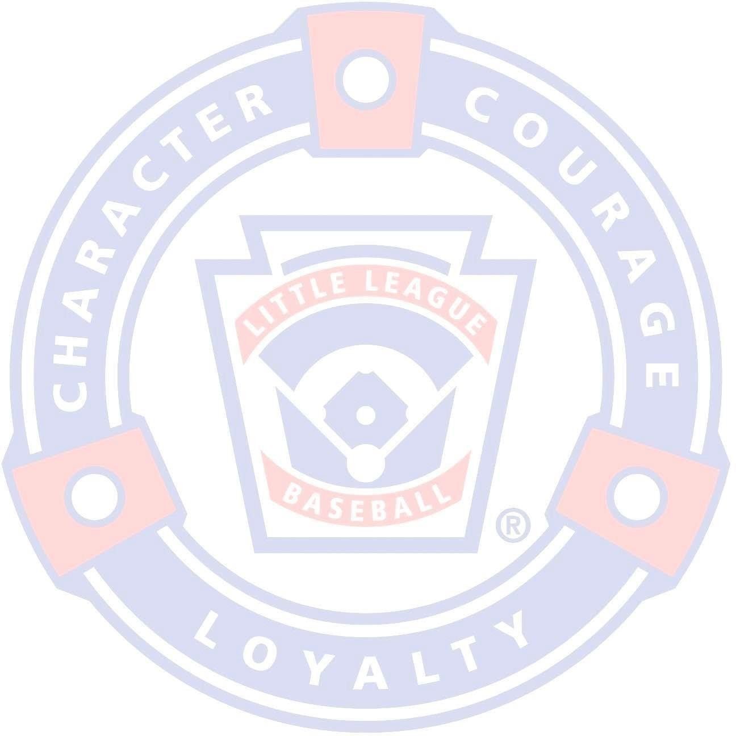
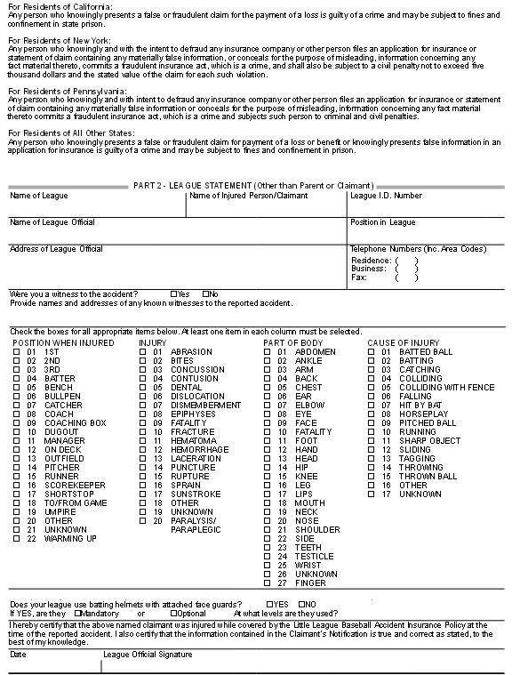

General Health
Medical Approval and Release - Although not required, the Medical Approval and Release form is provided to all managers. This form contains vital information regarding the child’s current general health, the child’s doctor’s name, address, and phone number, and any other special medical considerations (i.e. allergies, etc.). Managers are strongly encouraged to obtain a completed Release for each of the players on their team and are instructed to have these forms with them for every practice and game.

Communicable Disease Procedures - While the risk of one participant infecting another with HIV/AIDS during league activities is small, there is a remote risk other blood borne infectious diseases can be transmitted. Procedures for reducing the potential for transmission of infectious agents should include, but not limited to the following:

- Bleeding must be stopped, the open wound covered and if there is any extra amount of blood on the uniform, it must be changed before an athlete may participate.
- Routine use of gloves or other precautions to prevent skin and mucous membrane exposure when contact with blood or other body fluids is anticipated.
- Immediately wash hands and other skin surfaces and equipment with a solution made from a proper dilution of household bleach or other disinfectant before competition resumes.
- Practice proper disposal procedures to prevent injuries caused by needles and other sharp instruments or devices.
- Although saliva has not been implicated in HIV transmission, to minimize the need for emergency mouth-to-mouth resuscitation, mouthpieces, resuscitation bags, or other ventilation devices should be available for use.
- Managers, coaches, umpires and volunteers with bleeding or oozing skin should refrain from all athletic care until condition is resolved.
- Contaminated towels should be disposed of or disinfected properly.
- Follow acceptable guidelines in the immediate control of bleeding and when handling bloody dressings and other articles containing body fluids.

Copies of the Code of Conduct, the Safety Code, and the Manager’s Expectations are provided to each manager. It is expected that the manager provides each member of his or her team with a copy of each of these. The Code of Conduct and the Safety Code were listed previously in this document. The Manager’s Expectations can be found below.

Manager’s Expectations
What Do I Expect from My Players?
- To be on time for all practices and games.
- To always do their best whether in the field or on the bench.
- To always be cooperative and share team duties.
- To respect not only others, but themselves as well.
- To always be positive with teammates.
- To try not to become upset at their own mistakes or those of others…we will all make our share this year and we must support one another.
- To understand that winning is only important if you can accept losing, as both are important parts of any sport.

What Can You and Your Child Expect from Me?
- To be on time for all practices and games.
- To be as fair as possible for giving playing time to all players.
- To do my best to teach the fundamentals of the game.
- To be positive and respect each child as an individual.
- To set responsible expectations for each child and for the season.
- To teach the players the value of winning and losing.
- To be open to ideas, suggestions and help.
- To never holler at any member of my team, the opposing team or umpires. Any confrontation will be handled in a respectful, quiet and individual manner.

What Do I Expect from You as Parents and Family?
- To come out and enjoy the game. Cheer to make all players feel important.
- To allow me to coach and run the team.
- To try not to question my leadership. All players will make mistakes and so will I.
- Do not holler at me, the players, or the umpires. We are all responsible for setting examples for our children. We must be role models in society today. If we eliminate negative comments, the children will have an opportunity to play without any unnecessary pressures and will learn the value of sportsmanship.
- If you wish to question my strategies or leadership, please do not do so in front of players or fans. My phone number will be available for you to call at any time if you have a concern. It will also be available if you wish to offer your services at practice. A helping
hand is always welcome – a volunteer form is required!
Finally, don’t expect the majority of children playing Little League Baseball® to have strong skills. We hear all our lives that we learn from our mistakes. Let’s allow them to make their mistakes but always be there with positive support to lift their spirits!

Some Important Do’s and Don’ts
DO...
- Reassure and aid children who are injured, frightened or lost.
- Provide, or assist in obtaining medical attention for those who require it.
- Know your limitations.
- Carry your first-aid kit to all games and practices.
- - Assist those who require medical attention – and when administering aid, remember
to:
LOOK for signs of injury (Blood, Black-and-blue deformity of joint, etc.).
LISTEN to the injured describe what happened and what hurts if conscious. Before questioning, you may have to calm and soothe an excited child. FEEL gently and carefully the injured area for signs of swelling or grating of broken bone.
- Have your players’ Medical Release forms with you at all games and practices.
- Plan to have a cellular phone available when your game or practice is at a facility that does not have any public phones.

DON’T...
- Administer any medications.
- Provide any food or beverages (other than water).
- Hesitate in giving aid when needed.
- Be afraid to ask for help if you aren’t sure of the proper procedures (i.e. CPR, etc.).
- Transport injured individuals except in extreme emergencies.
- Leave an unattended child at a practice or game.
- Hesitate to report any present or potential safety hazard to the Safety Officer immediately.

Lightning Safety
The quick and easy approach for lightning is “if you see it, flee it; if you hear it, clear it.” Lightning can travel up to 10 miles from the storm’s edge, so if it is seen or heard, the fields should be cleared and the game pauses to wait for the lightning to pass. All individuals are required to clear the fields and seek shelter – away from trees. At the JCLL complex, individuals should move to the overhang under the concession stand. If lightning is not seen for a reasonable time (usually 30 minutes), the game can continue. Players should be instructed to stay until the game is cancelled, so all players are accounted for while a game is in storm delay. In addition, JCLL does own and utilizes a lightning detector during inclement weather.

Storage Container Procedures
The following applies to all the storage areas used by JCLL and apply to anyone who has been issued a key by JCLL to use those areas.
All individuals with keys to the JCLL equipment sheds (i.e. Managers, Umpires, etc.) are aware of their responsibilities for the orderly and safe storage of rakes, shovels, bases, etc.

Remember, safety is everyone’s job. Prevention is the key to reducing accidents to a minimum. Report all hazardous conditions to the Safety Officer or another Board member immediately. Don’t play on a field that is not safe or with unsafe playing equipment. Be sure your players are fully equipped at all times, especially catchers and batters. And check your team’s equipment often. Locking the storage containers is always mandatory.

Conclusion
I wish to thank all of you who helped make last season at Jefferson County Little League a safe and rewarding year and look forward to working with all of you in the current season. Remember, safety is everyone’s job and prevention is the key to reducing accidents. If you ever have a question or suggestion, please don’t hesitate to contact me. Thank you and let’s make this year the best in our 60+ years of Jefferson County Little League.

Sincerely,
Bryan Sutherland
President

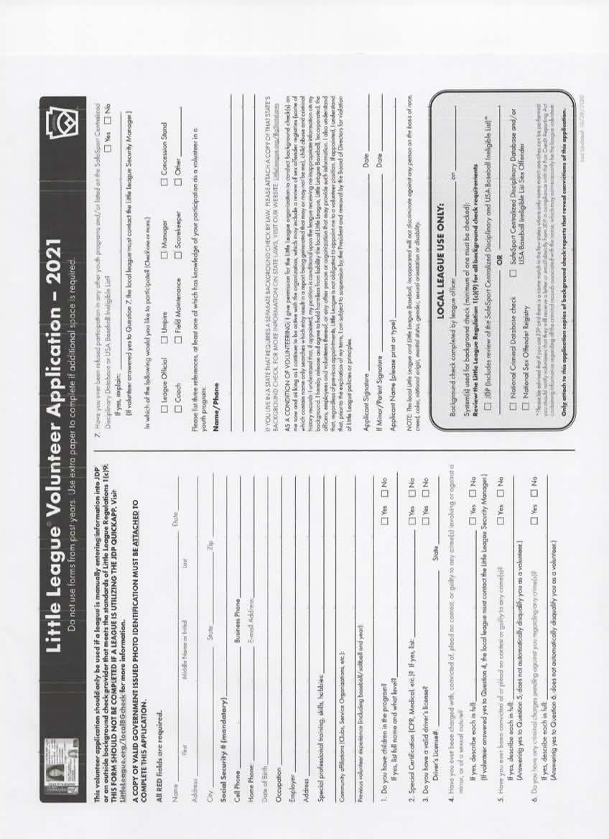
Appendix A Volunteer Form

Appendix B – Injury Tracking Form
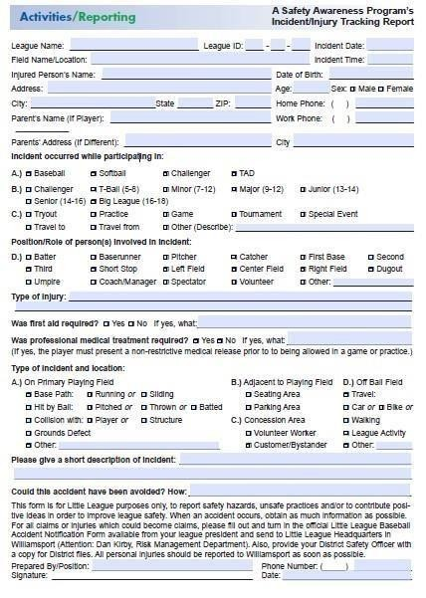

Appendix C – Medical Release Form
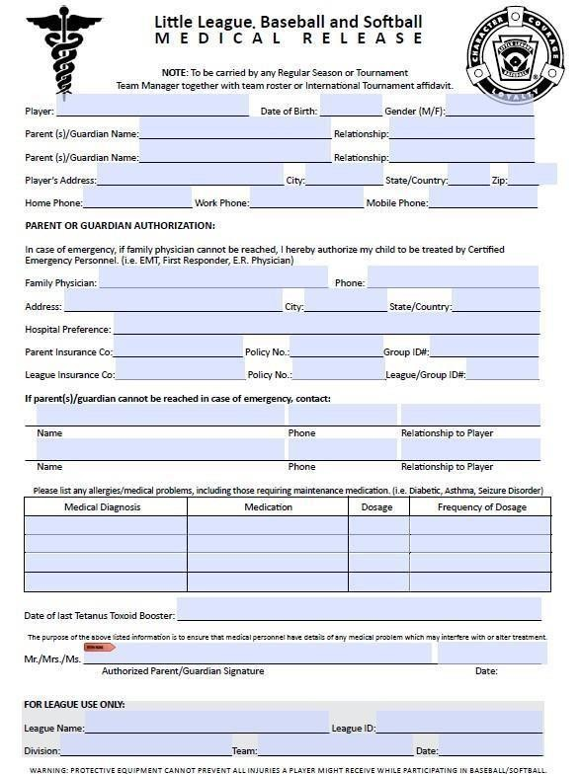

Appendix D – General Liability Claim Form
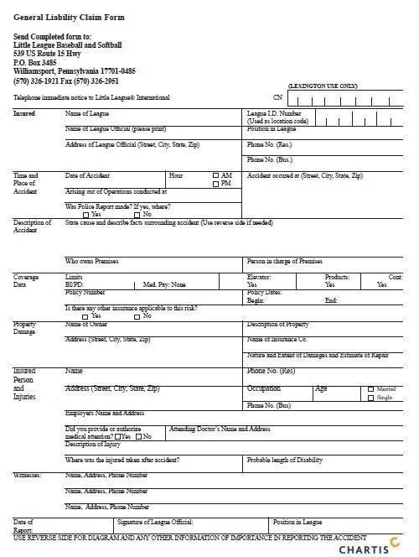

Appendix E – Concession Stand Safety
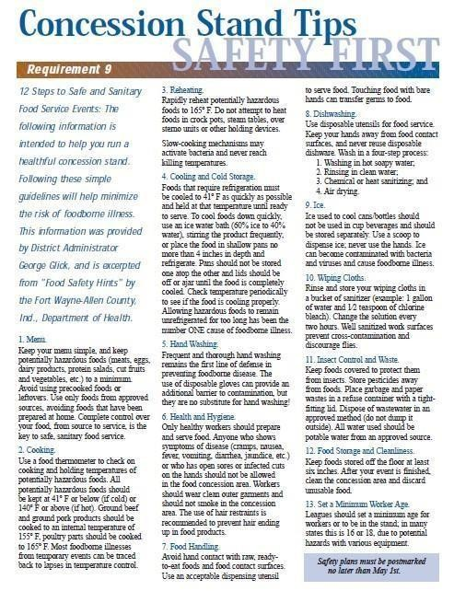

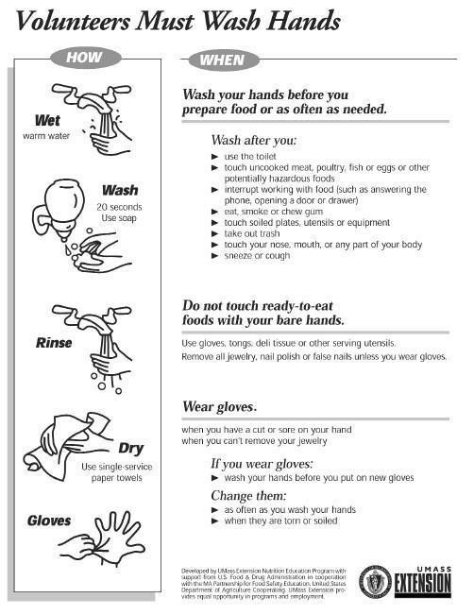

First Aid
All JCLL managers and coaches will receive first-aid training before the season begins. First Aid kids will be distributed to the managers at the beginning of the season. Ice and bandages are also available at the concession stand. At least one representative of each team must attend. Managers must have a first-aid kit at every game of practice.

Little League Baseball uses an acronym called PRICES to help remember the basics of first aid:

- Protection – When a player feels pain or just “something wrong”, he or she should stop immediately to protect the area from further harm. If a player “plays thru the pain”, he or she risks further injury, delayed recovery and more pain.
- Rest – Not playing until recovery is complete; don’t use the arm, stay off the leg, or use a crutch to properly rest a limb if appropriate.
- Ice – Should be applies as soon after an injury to reduce swelling and inflammation. Apply ice for no more that 5-10 mins and then remove for 5-10 mins, repeating the cycle several times Apply the ice over a towel or other dressing, and make sure the skin does not come in direct contact with the ice. Ice the area several times each day. Be careful to watch the skin color to avoid damage to the skin; when the skin is pimk for light skinned players or darker for dark skinned players, remove the ice.
- Compress – the injured area to further reduces swelling, which if not controlled can put pressure on muscles and connective tissues, causing damage. Use elastic bandages, air casts or splints. This should be done carefully as circulation can be restricted if done improperly; if throbbing begins, loosen the wrapping.
- Elevate – the area when possible above the heart to further reduce swelling
- Support – keep the limb supported and protected from further harm.

Appendix F – General Safety
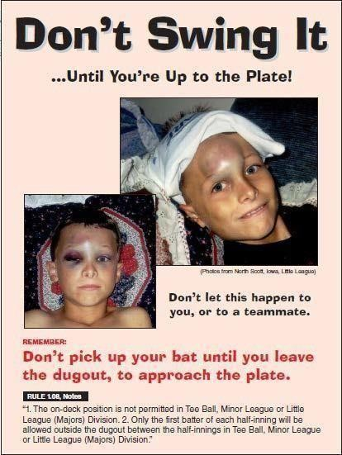

Note: On-Deck batters are NOT permitted! The only player with a bat in their hands should be the batter on the field

Appendix G – Head Injuries
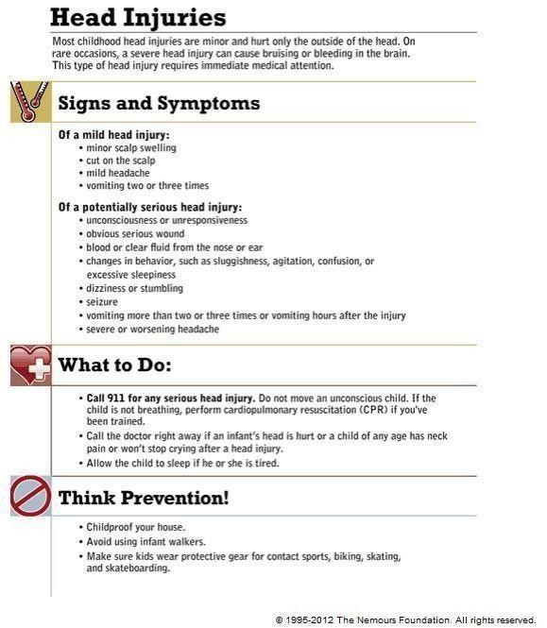

Appendix H – Dislocations
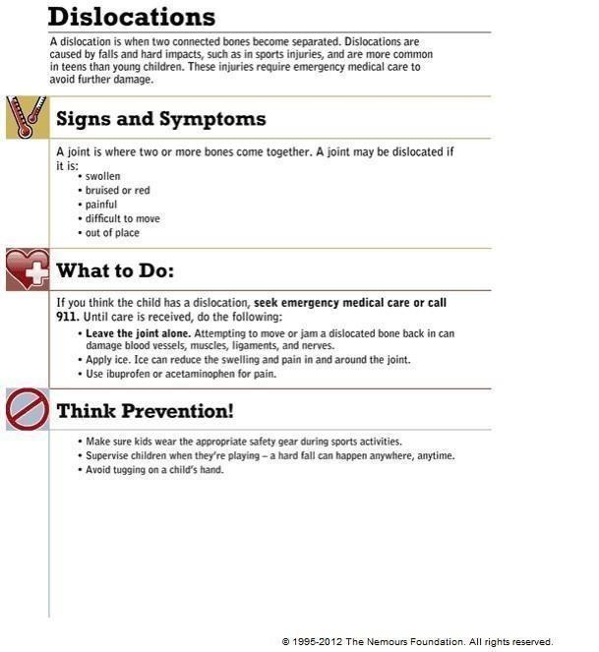

Appendix I – Broken Bones
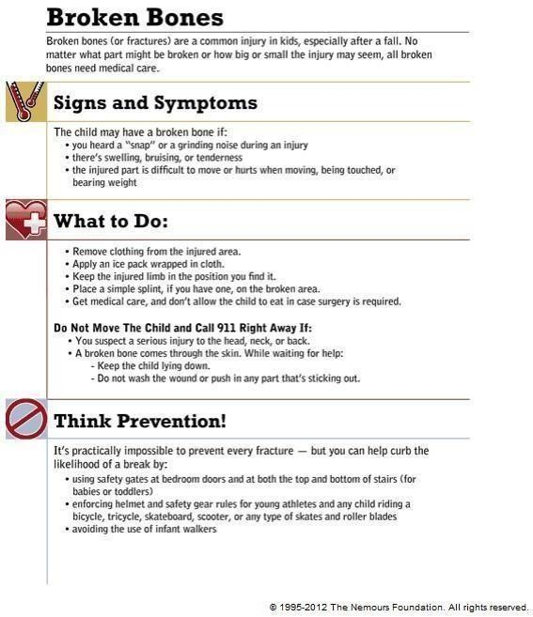

Appendix J – Strains and Sprains
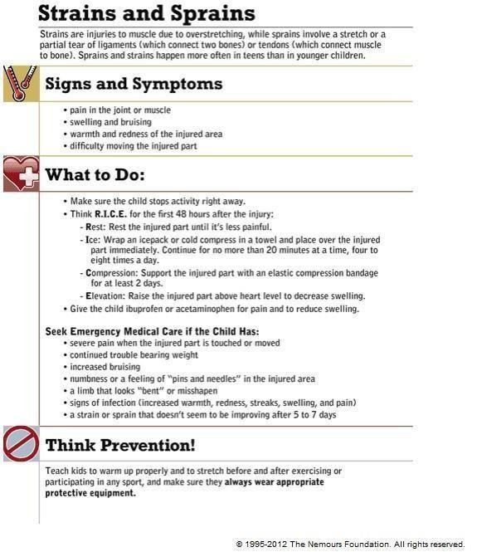

Appendix K – Nosebleeds
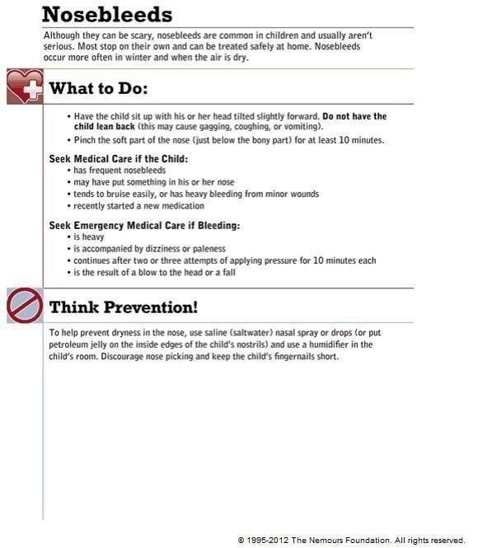

Appendix L – Cuts
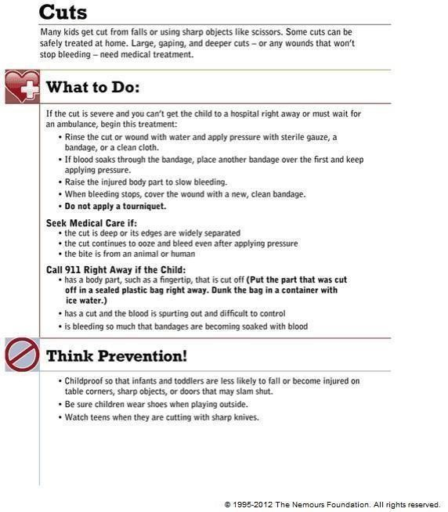

Appendix M – Dehydration
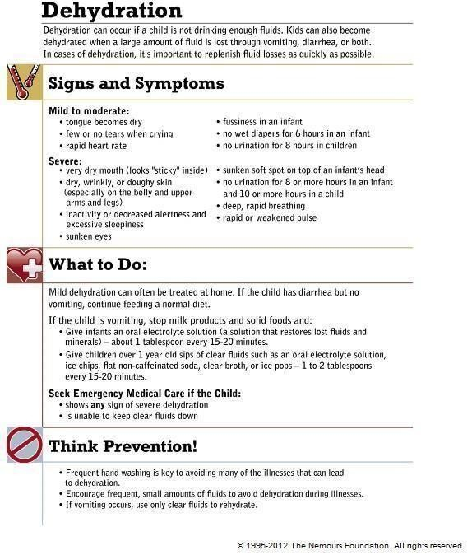

Appendix N – Heat Illness
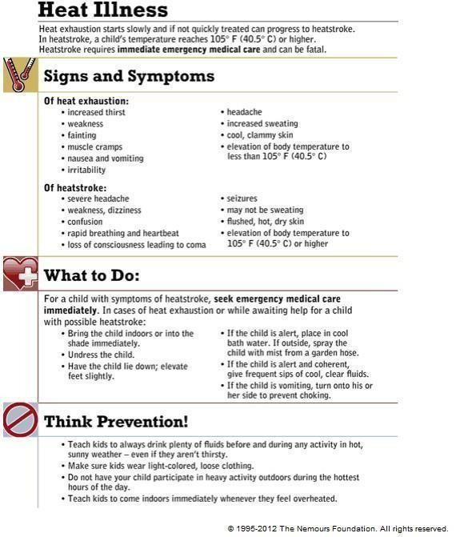

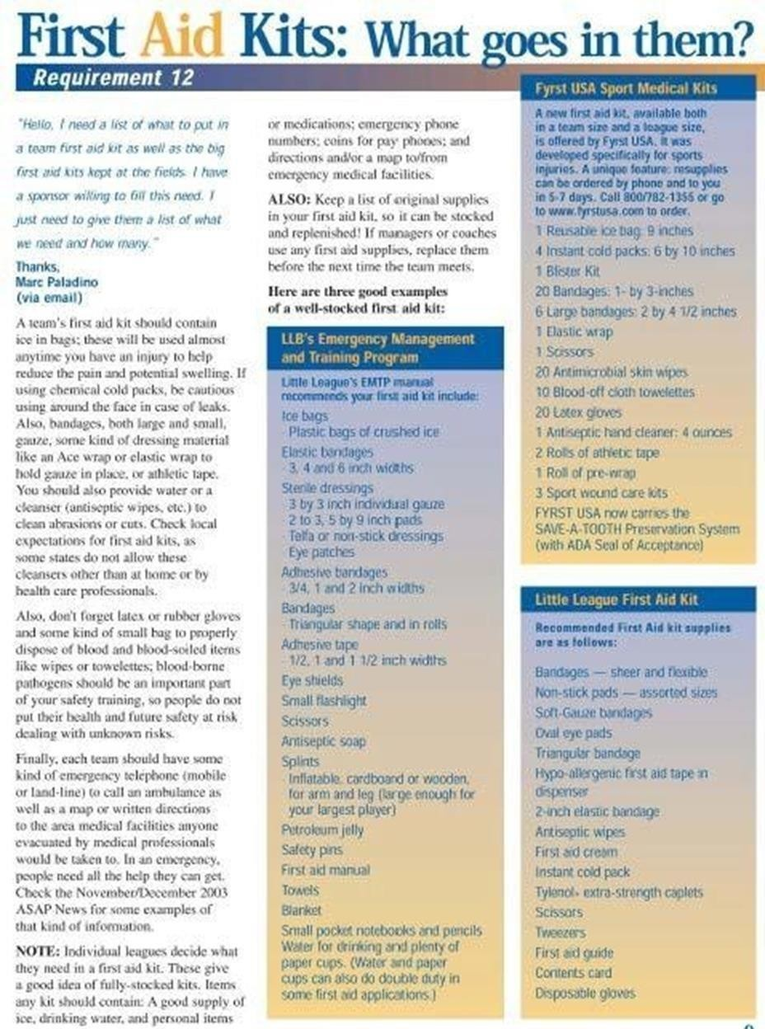
Apendix

O

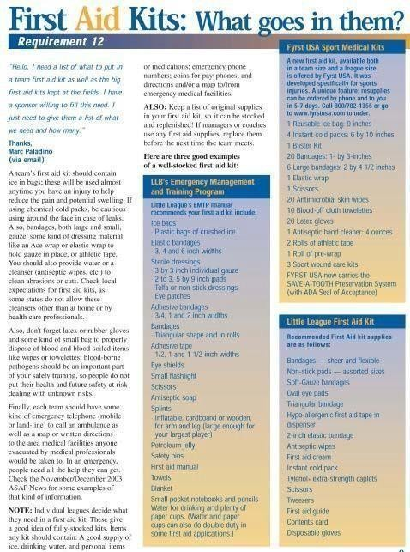 P
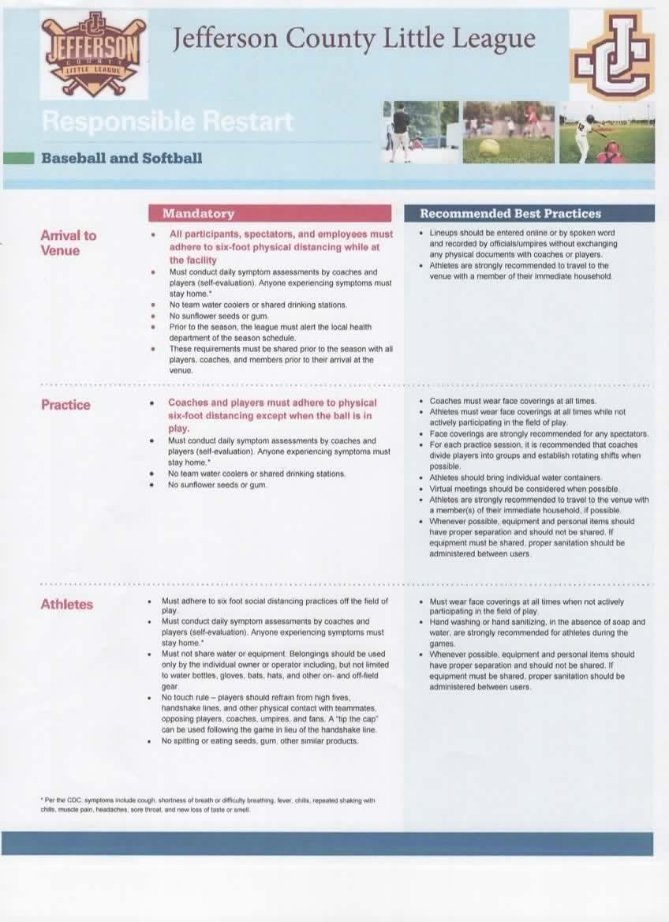
Appendix P

Covid Policies

and

Guidelines

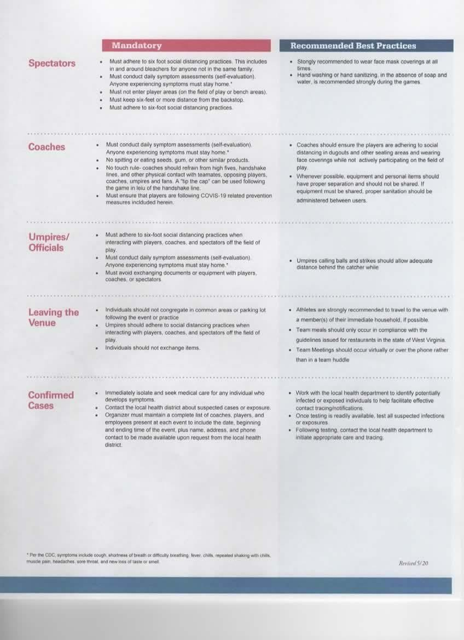
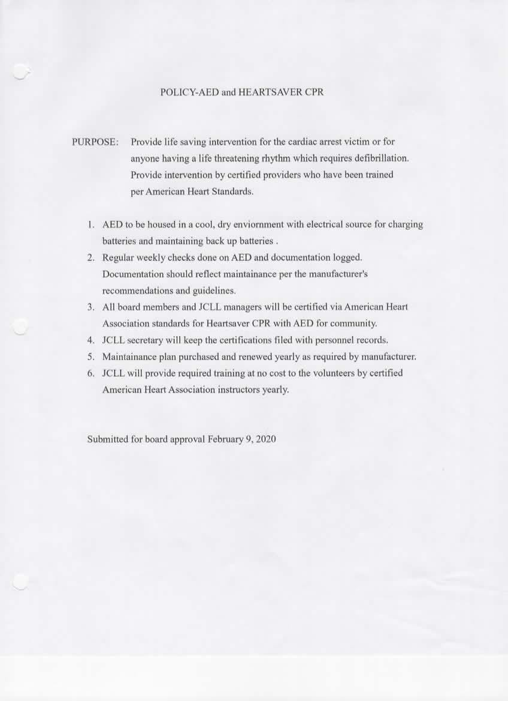
Appendix Q AED Policies

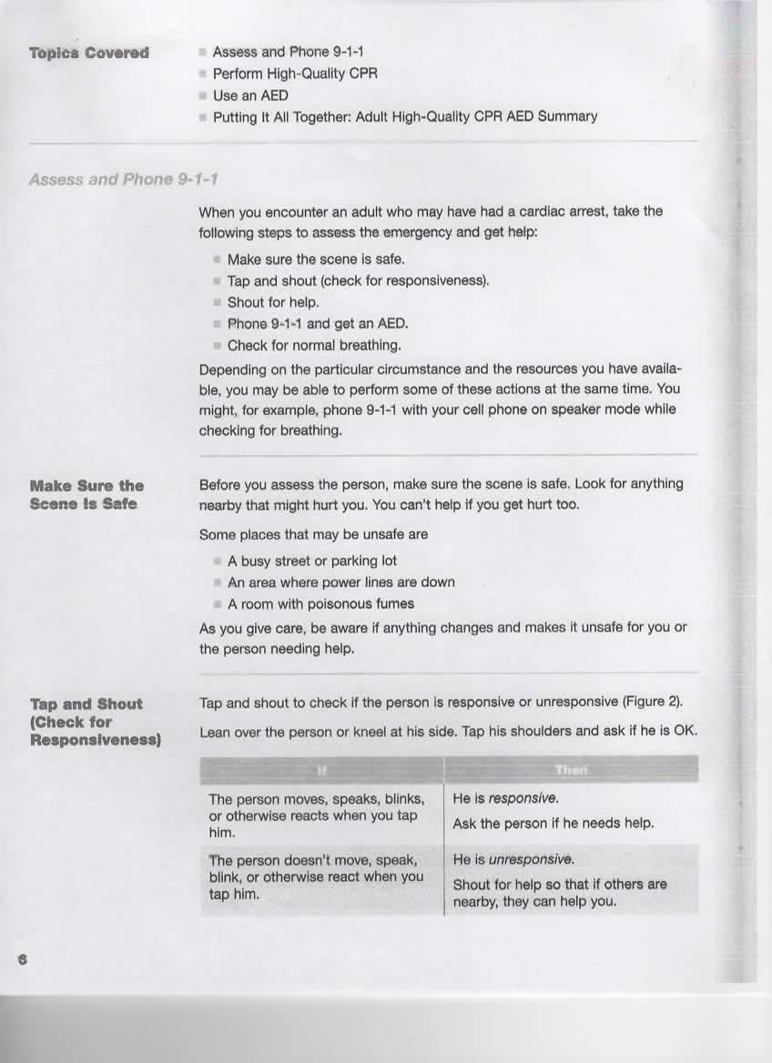

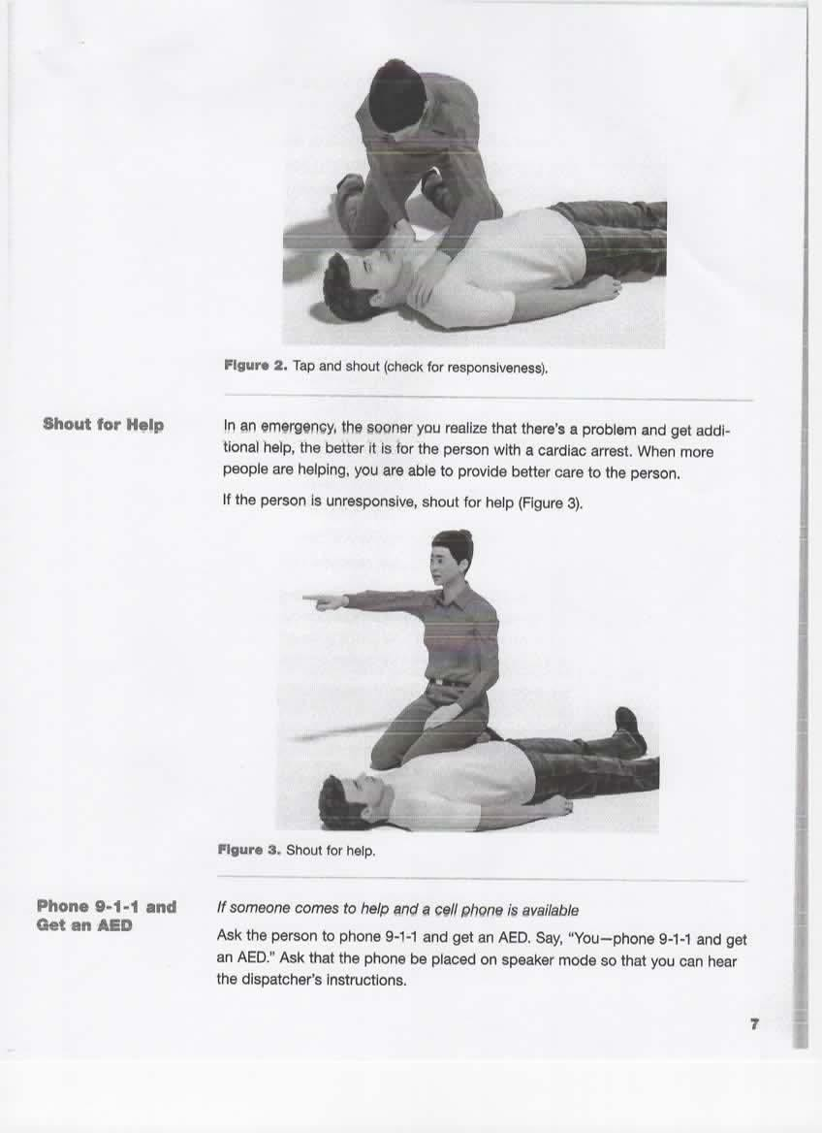
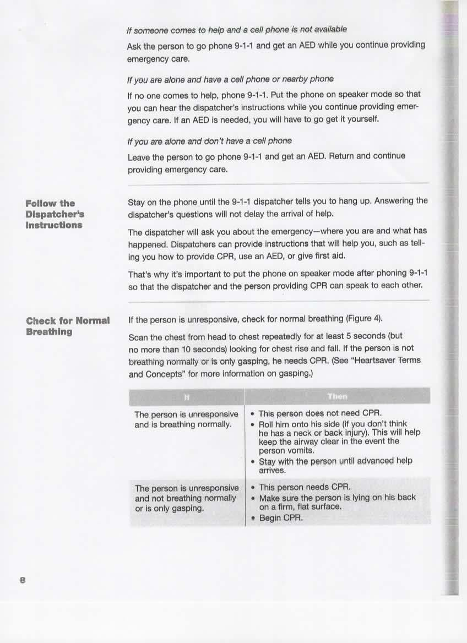
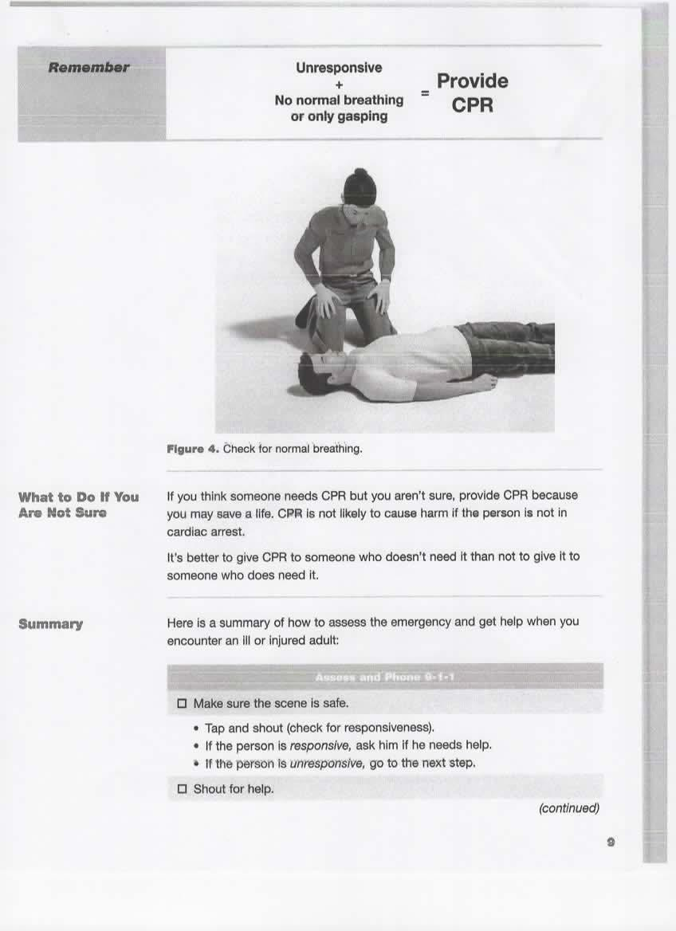
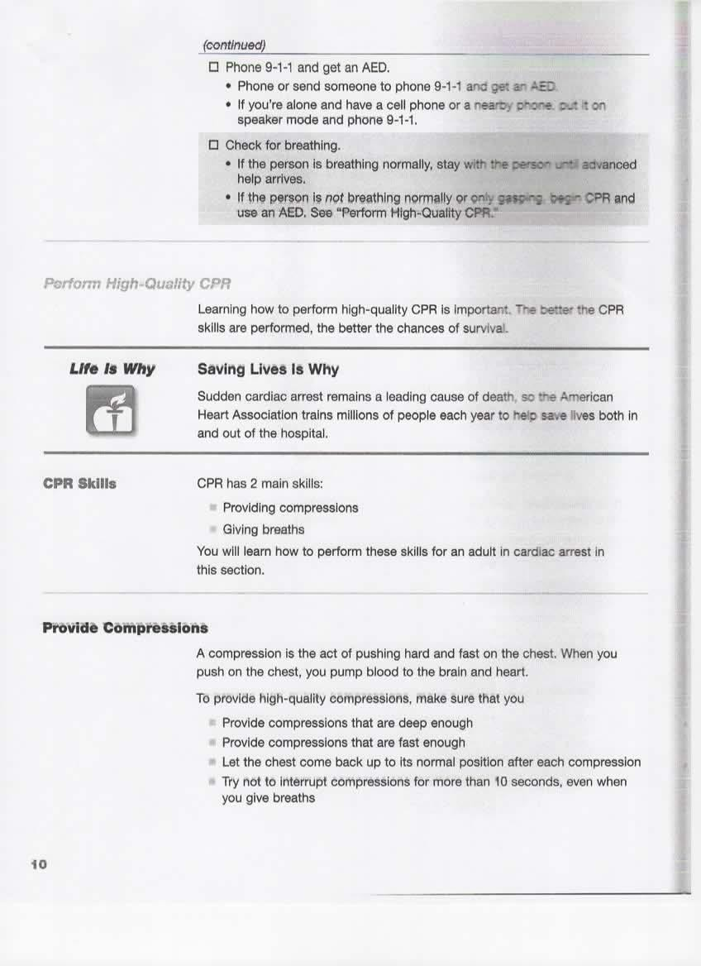
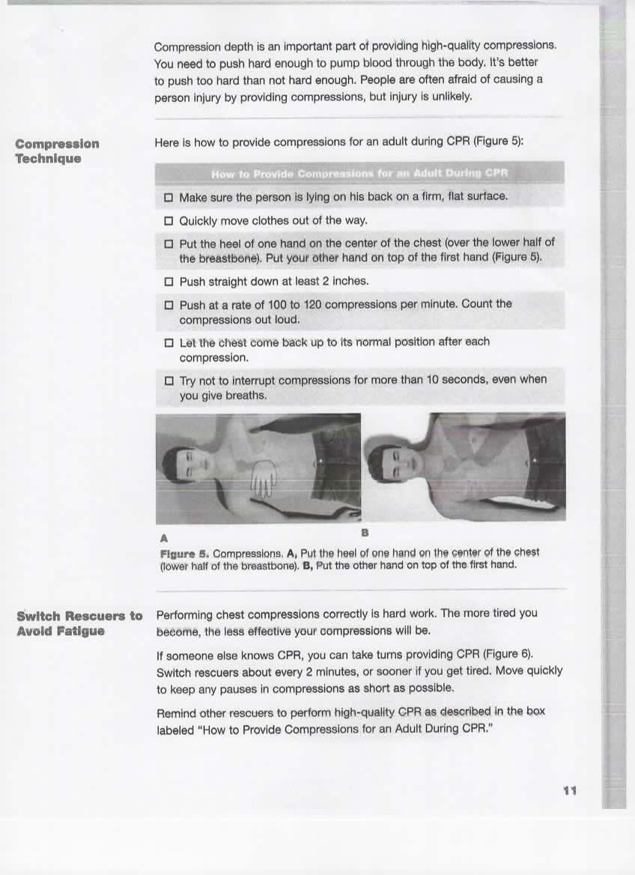
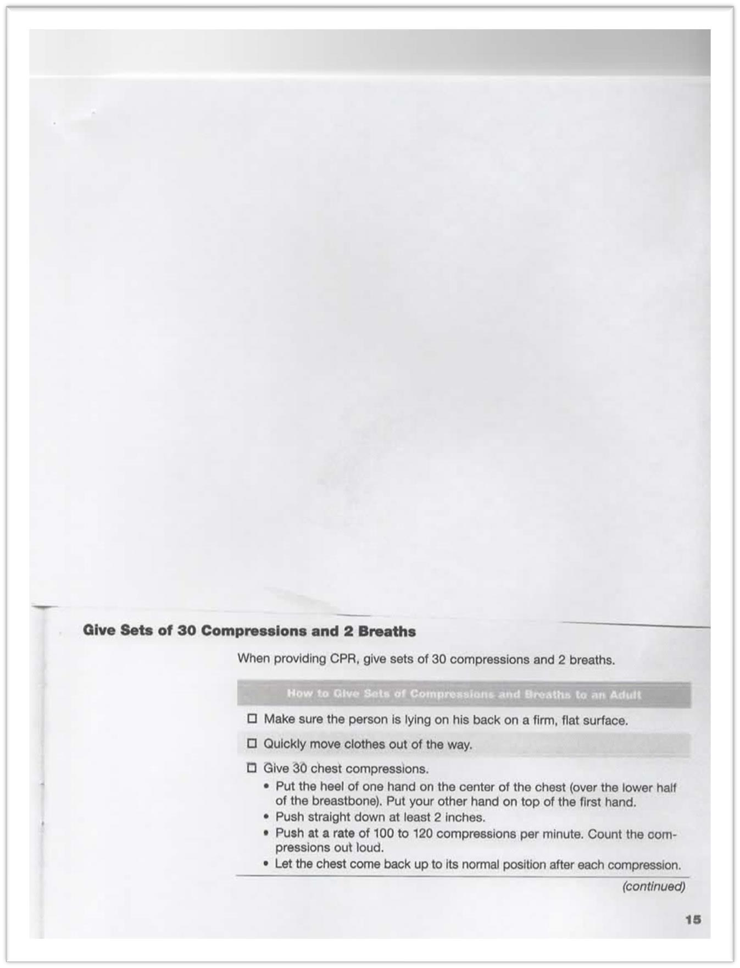
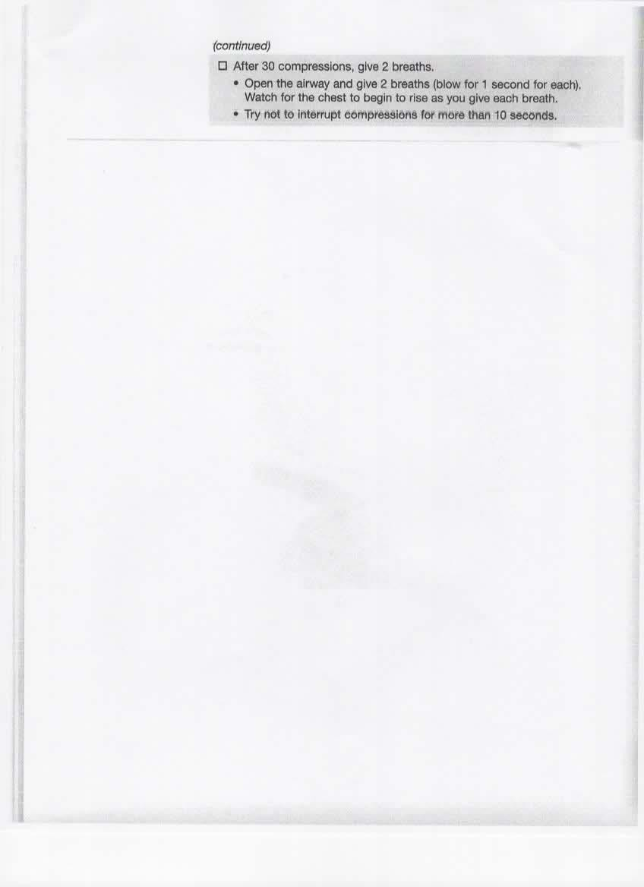
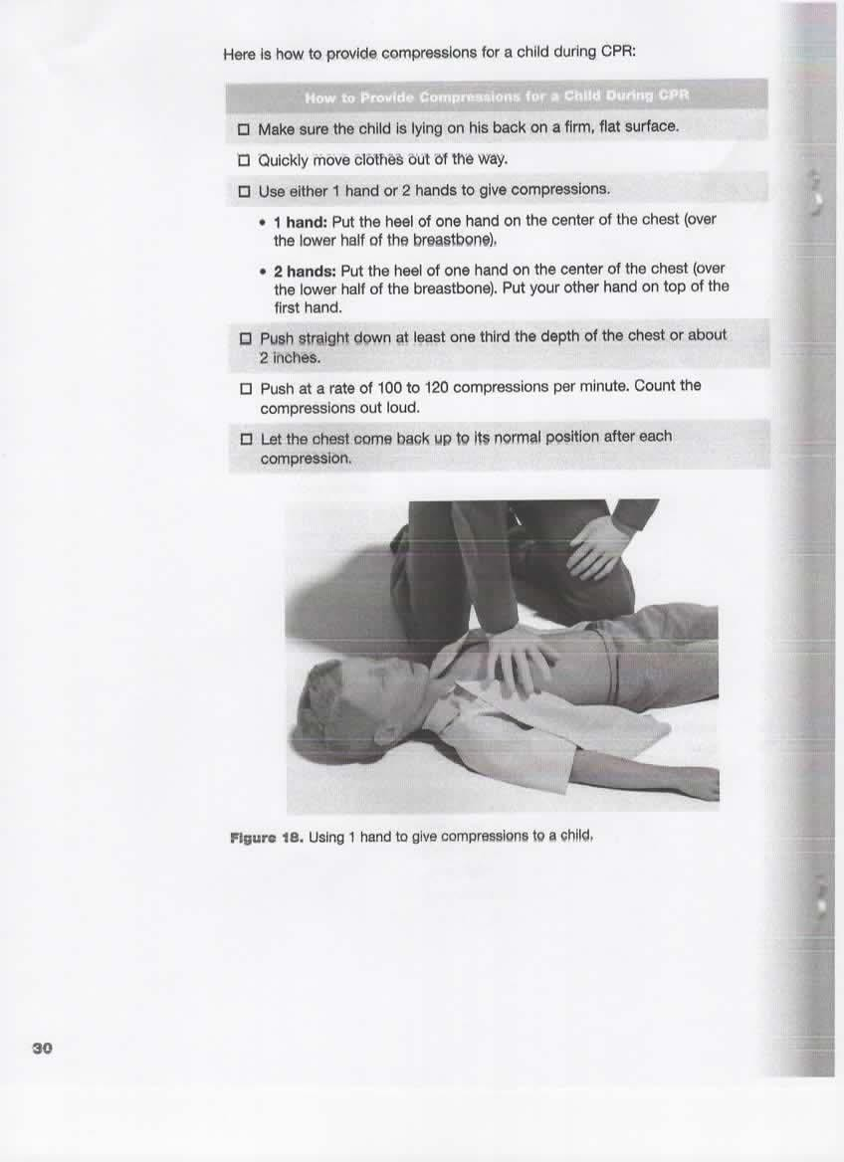
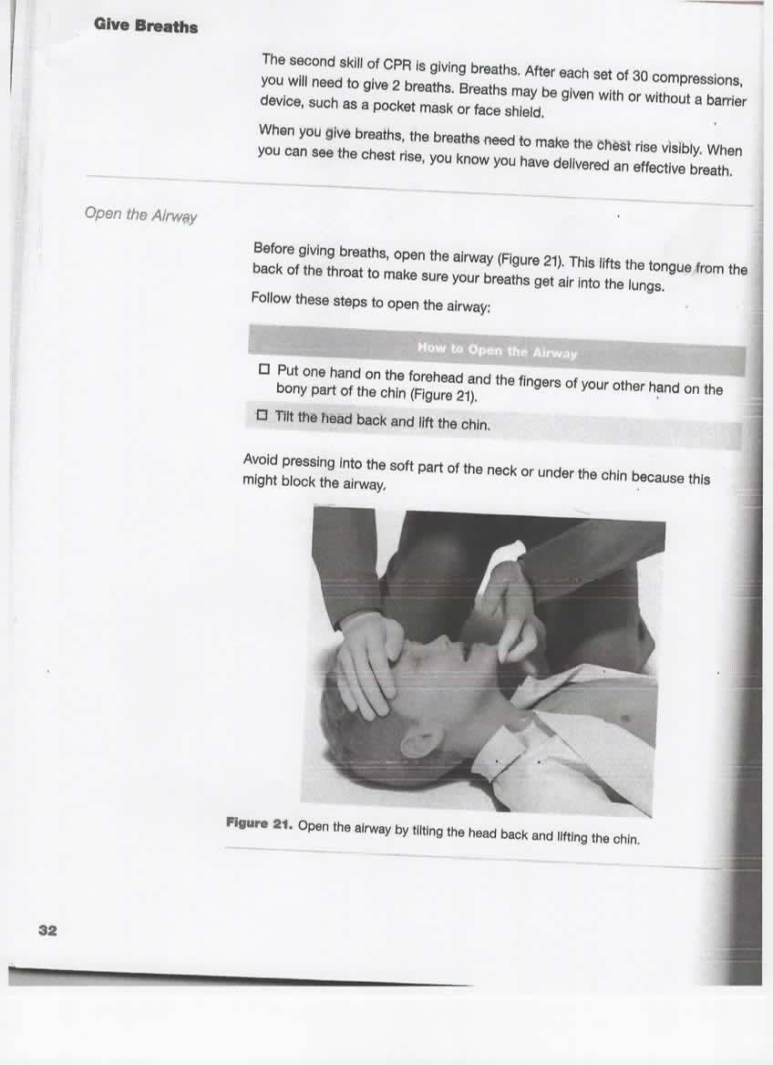
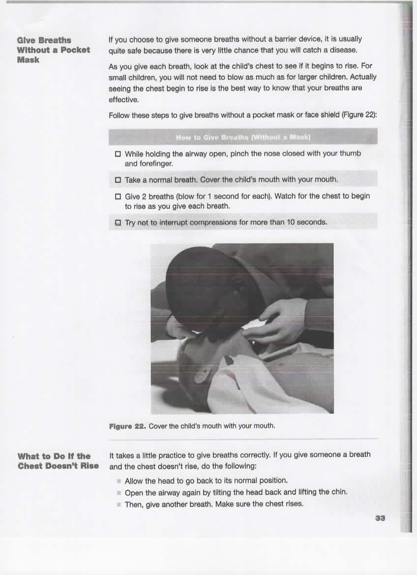
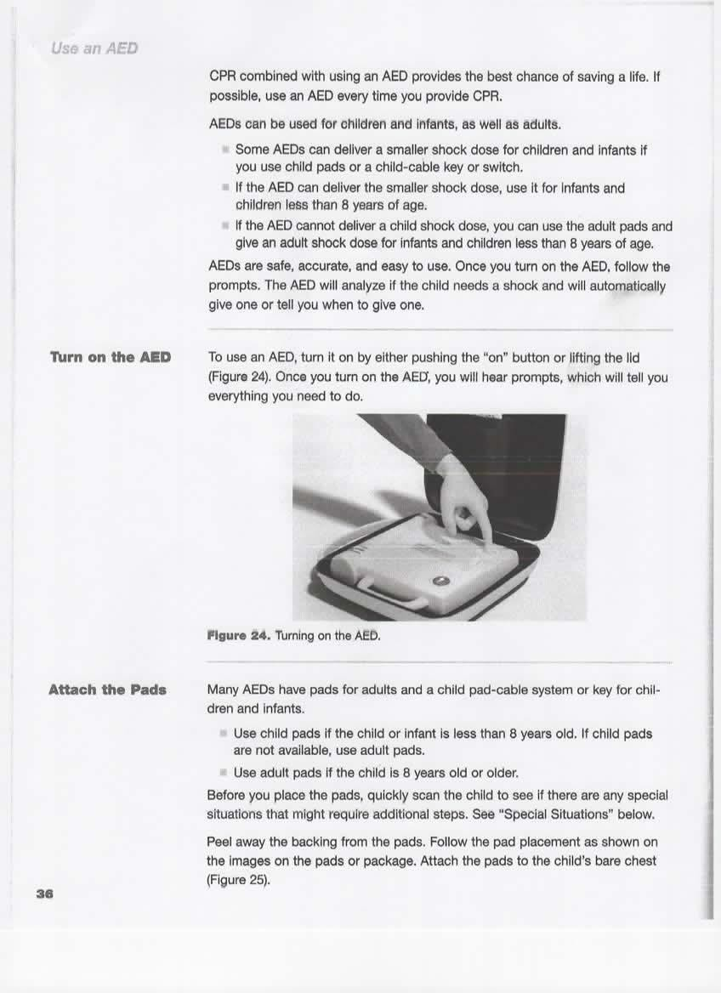
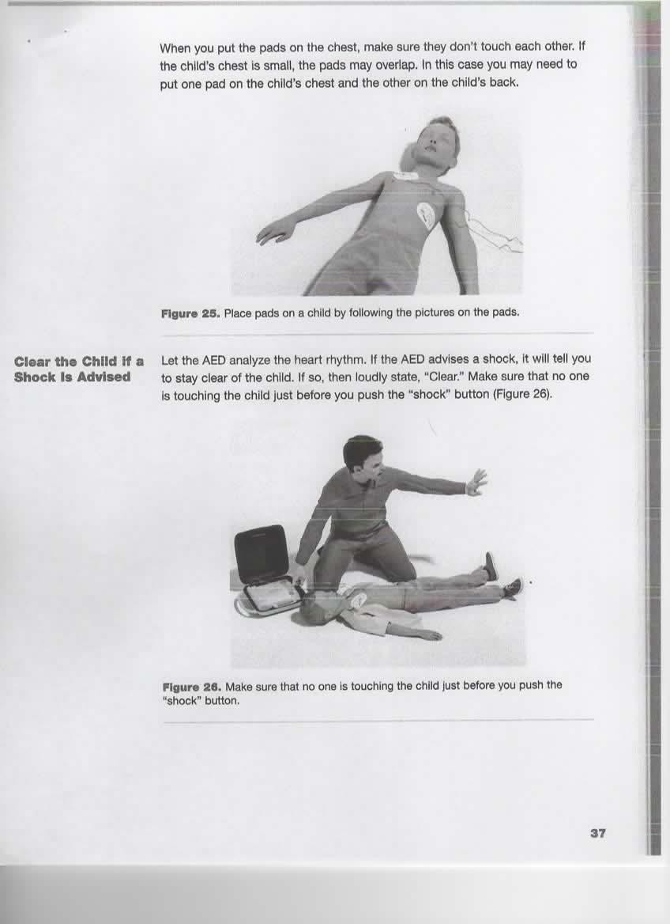
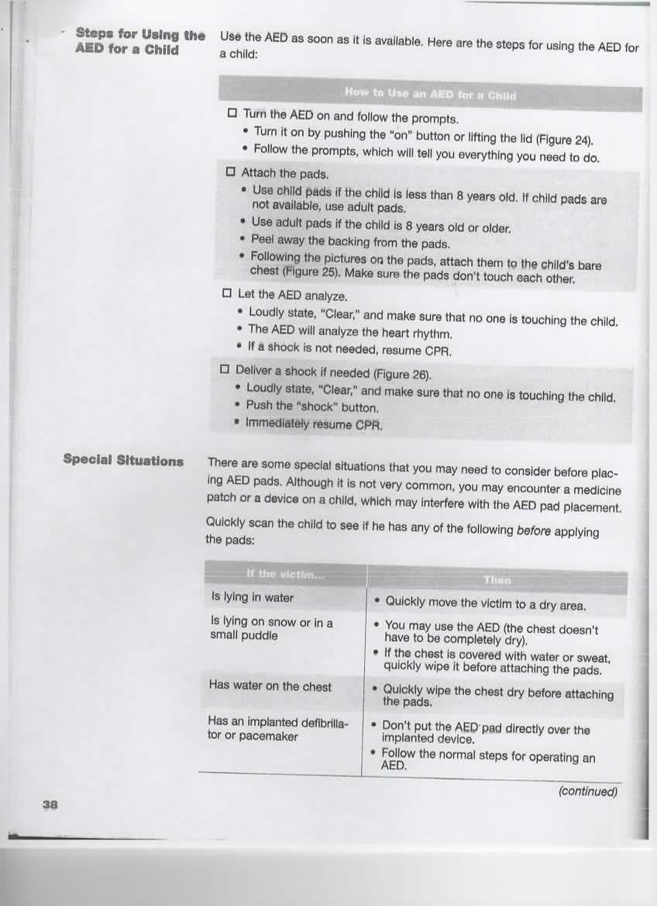
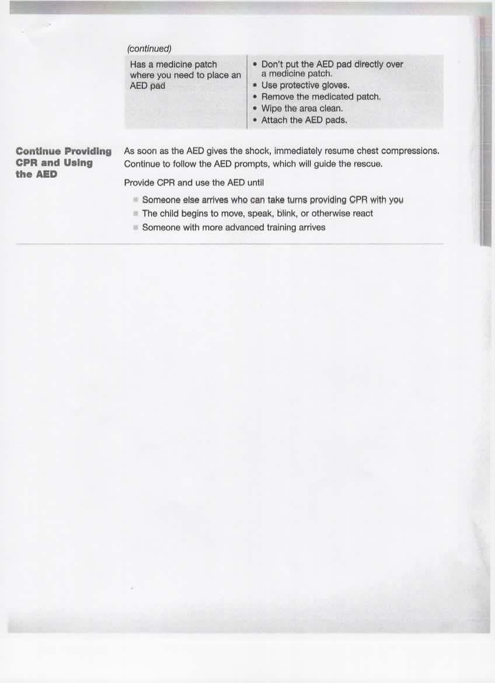
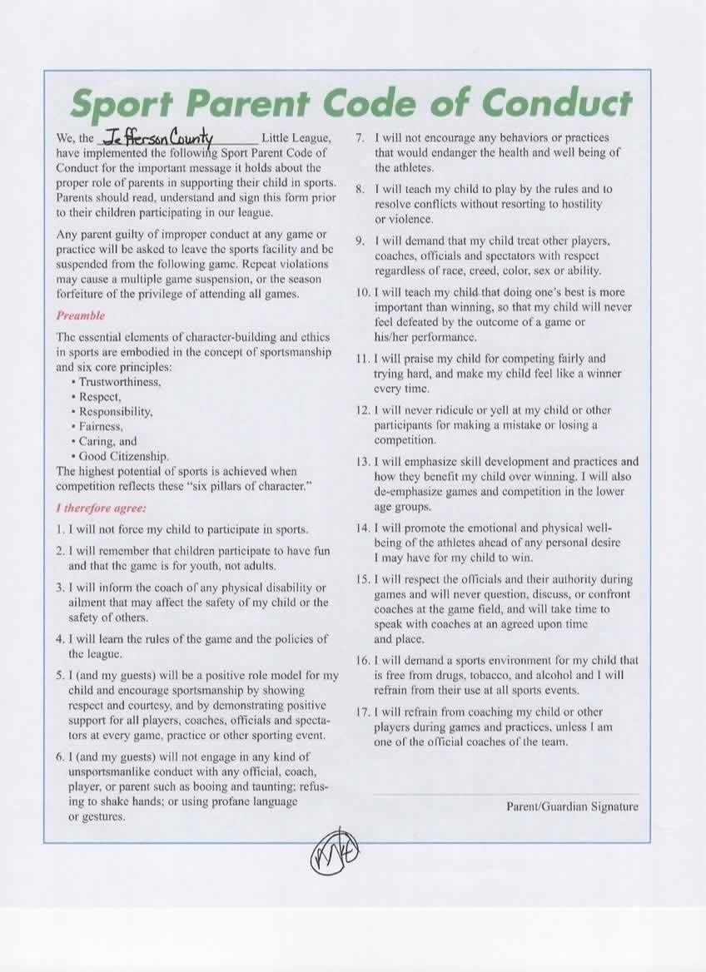
Addendum regarding Covid-19

We at the Jefferson County Little League take our role of responsibility to manage the season during covid 19 very seriously. We will continue to monitor the latest guidelines from the West Virginia Department of Health and the Jefferson County school board. Since our complex is situated on school property, we will be following their rules; however, we may have rules in place that exceed the quarantine times of the schools due to the nature of our exposures and tracking procedures. Please help us to keep your children safe and promote a safe Little League baseball season.

Thank you,

Keith Kain Jr
Safety Coordinator JCLL

